Computer System

Definition
# Source: AI Source: Provided by: [Data Path: Persons Table -> ID Column: 1, Name_En Column: Motasem Essam] -> From: [ChatGPT] on [4/22/2026]
A computer system is a complete setup of hardware, software, and users that work together to process data and produce useful information.

🧠 Simple idea
# Source: AI Source: Provided by: [Data Path: Persons Table -> ID Column: 1, Name_En Column: Motasem Essam] -> From: [ChatGPT] on [4/22/2026]
A computer system is not just the computer itself—it includes everything needed to make it work and be useful.

🔄 Main components of a computer system
# Source: Academic source: Provided by: [Data Path: Persons Table -> ID Column: 1, Name_En Column: Motasem Essam] -> From: [Data Path: Sources Table -> ID Column: 158, Content Title Column: Academic Source - Modern academy - 2017-2018 - Intro to Computer Science - Computer systems] -> at: [Document, page: 3, all, “Image - Tool: [Lightshot Program]”] on [4/22/2026]
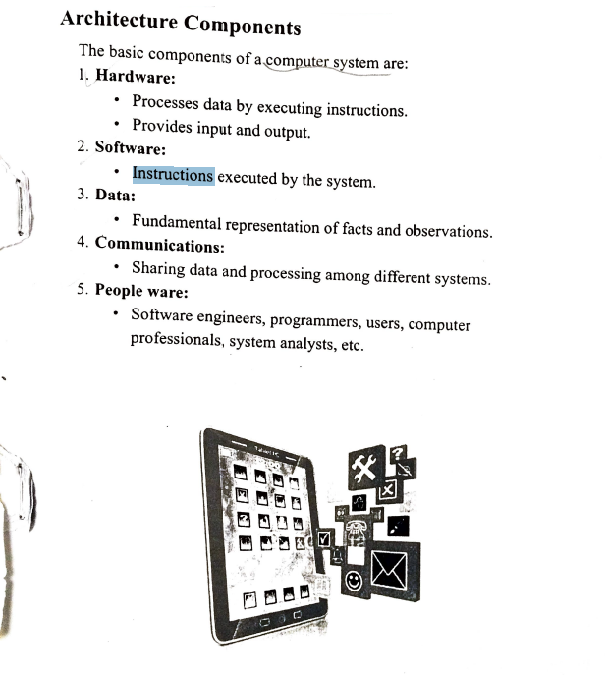/

🖥️ 1. Hardware (physical parts)
# Source: AI Source: Provided by: [Data Path: Persons Table -> ID Column: 1, Name_En Column: Motasem Essam] -> From: [ChatGPT] on [4/22/2026]
These are the physical devices:
- CPU (processor)
- Monitor, keyboard, mouse
- Storage (SSD/HDD)
- Input/output devices

💾 2. Software (programs)
# Source: AI Source: Provided by: [Data Path: Persons Table -> ID Column: 1, Name_En Column: Motasem Essam] -> From: [ChatGPT] on [4/22/2026]
These are the instructions and programs:
- Operating system (Windows, Linux, Android)
- Applications (browsers, games, apps)
- System software that controls hardware

👤 3. People (users)
# Source: AI Source: Provided by: [Data Path: Persons Table -> ID Column: 1, Name_En Column: Motasem Essam] -> From: [ChatGPT] on [4/22/2026]
- The humans who use the computer
- Example: students, engineers, gamers, office workers

📊 4. Data
# Source: AI Source: Provided by: [Data Path: Persons Table -> ID Column: 1, Name_En Column: Motasem Essam] -> From: [ChatGPT] on [4/22/2026]
- Raw facts and figures entered into the system
- Example: numbers, text, images, audio

⚙️ 5. Procedures
# Source: AI Source: Provided by: [Data Path: Persons Table -> ID Column: 1, Name_En Column: Motasem Essam] -> From: [ChatGPT] on [4/22/2026]
- The rules or steps for using the system properly
- Example: login steps, file saving rules

🔄 How a computer system works
# Source: AI Source: Provided by: [Data Path: Persons Table -> ID Column: 1, Name_En Column: Motasem Essam] -> From: [ChatGPT] on [4/22/2026]
$$\text{Input (Data)}→\text{Processing (CPU + Software)}→\text{Output (Information)}$$

🌍 Real-life example
# Source: AI Source: Provided by: [Data Path: Persons Table -> ID Column: 1, Name_En Column: Motasem Essam] -> From: [ChatGPT] on [4/22/2026]
- You type on a keyboard (input)
- The computer processes it using software
- Text appears on the screen (output)
- You (user) interact with it

🧾 One-line definition
# Source: AI Source: Provided by: [Data Path: Persons Table -> ID Column: 1, Name_En Column: Motasem Essam] -> From: [ChatGPT] on [4/22/2026]
A computer system is a combination of hardware, software, data, and users working together to process information.

